**Cloud Formation**

**What is Cloud Formation:-**

Cloud Formation is an infrastructure automation platform for AWS that makes deploying AWS resources at a much faster, more efficient, and more secure scale.

Using Cloud Formation, you can manage your whole AWS environment by developing templates that specify the AWS settings you want to use.

The Cloud Formation is only for AWS Cloud provider.

The Cloud Formation is only support for JSON and YAML file Format.

**Benefits of AWS Cloud Formation:-**

* **Reduced time spent on resource management**
* **Increased efficiency and consistency**
* **Infrastructure as code**
* **Improved collaboration and documentation**
* **Easy updates**
* **Auditing and change management**
* **Security**

Overall, AWS Cloud Formation can save you time and effort in provisioning and managing your AWS resources.

**Important Points:-**

The Cloud Formation is only support for JSON and YAML files format only.

We must our code template should be present in JSON or YAML file format.

We must check the availability zone while creation new services and also check the private key (pem key) are present or not in our required availability zone. In case we don’t have pem key then create pem key for our required region.

**Now we create an AWS EC2 with Cloud Formation and installing MySQL in the server**

**START:**

First we login AWS console and in that search bar search Cloud Formation

And click on it.

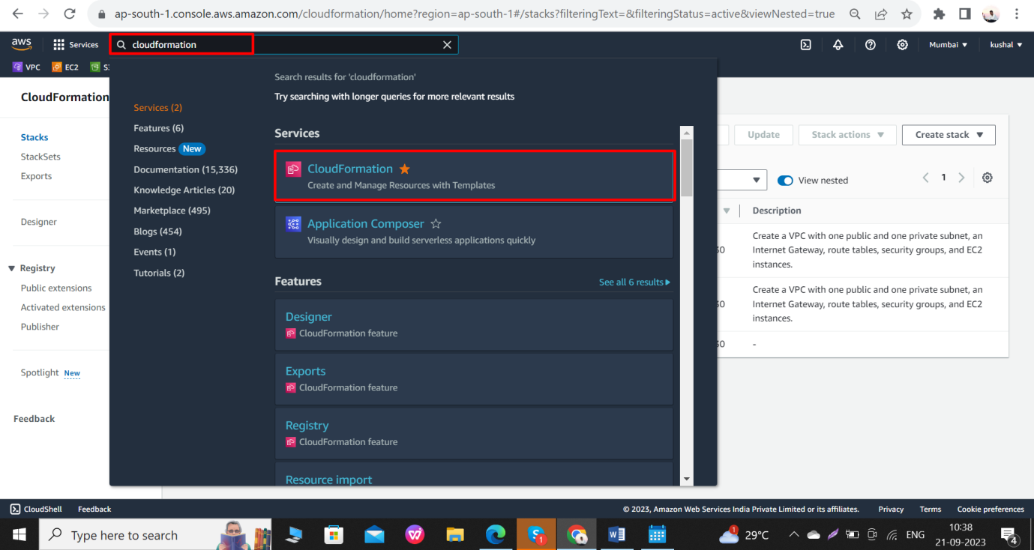

Next we select stacks and click on create stack.

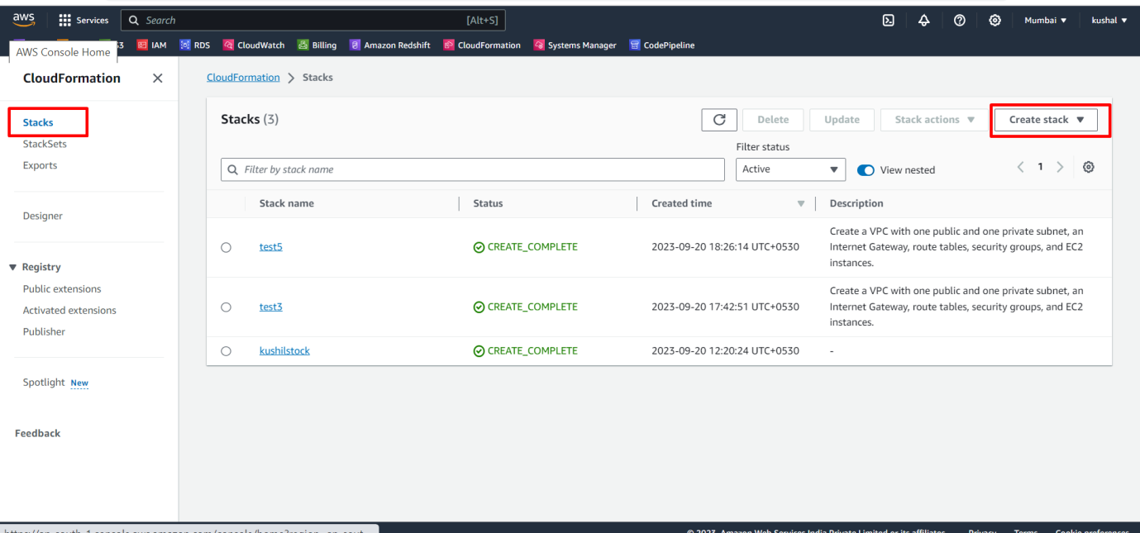

If you have some code template then select the **Template is ready**. If you don’t have code template and you create new template for your requirements then select **create template in designer**.

Here I already have code template so I select **Template is ready**.

And select **upload a template file** next click on **chose file** and select your code template file for uploading.

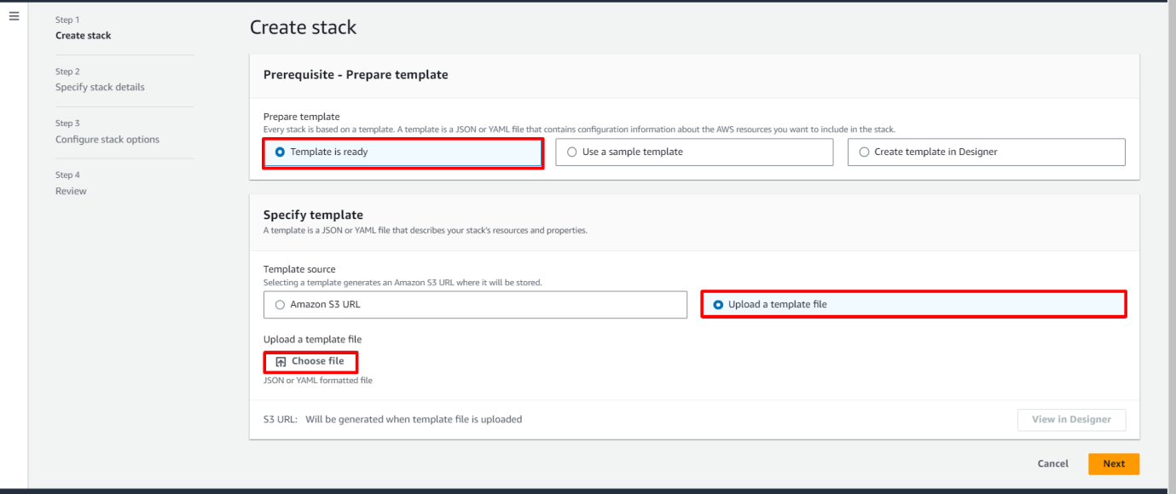

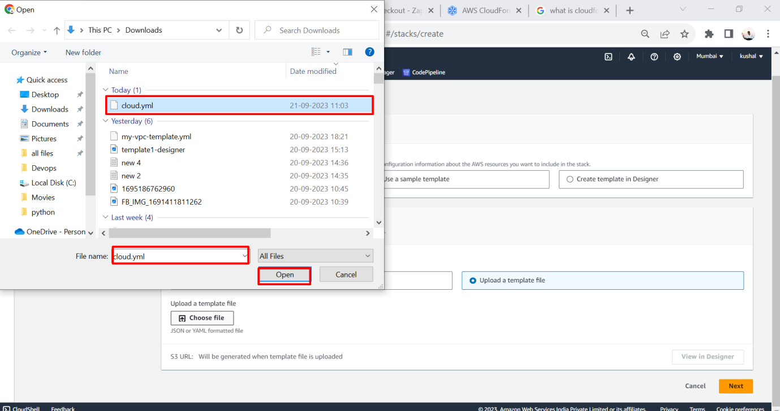

Then Click on next

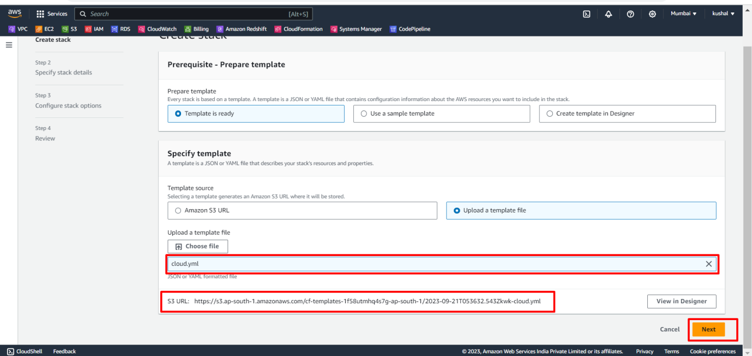

**NOTE:- The cloud.yml file contains this code**

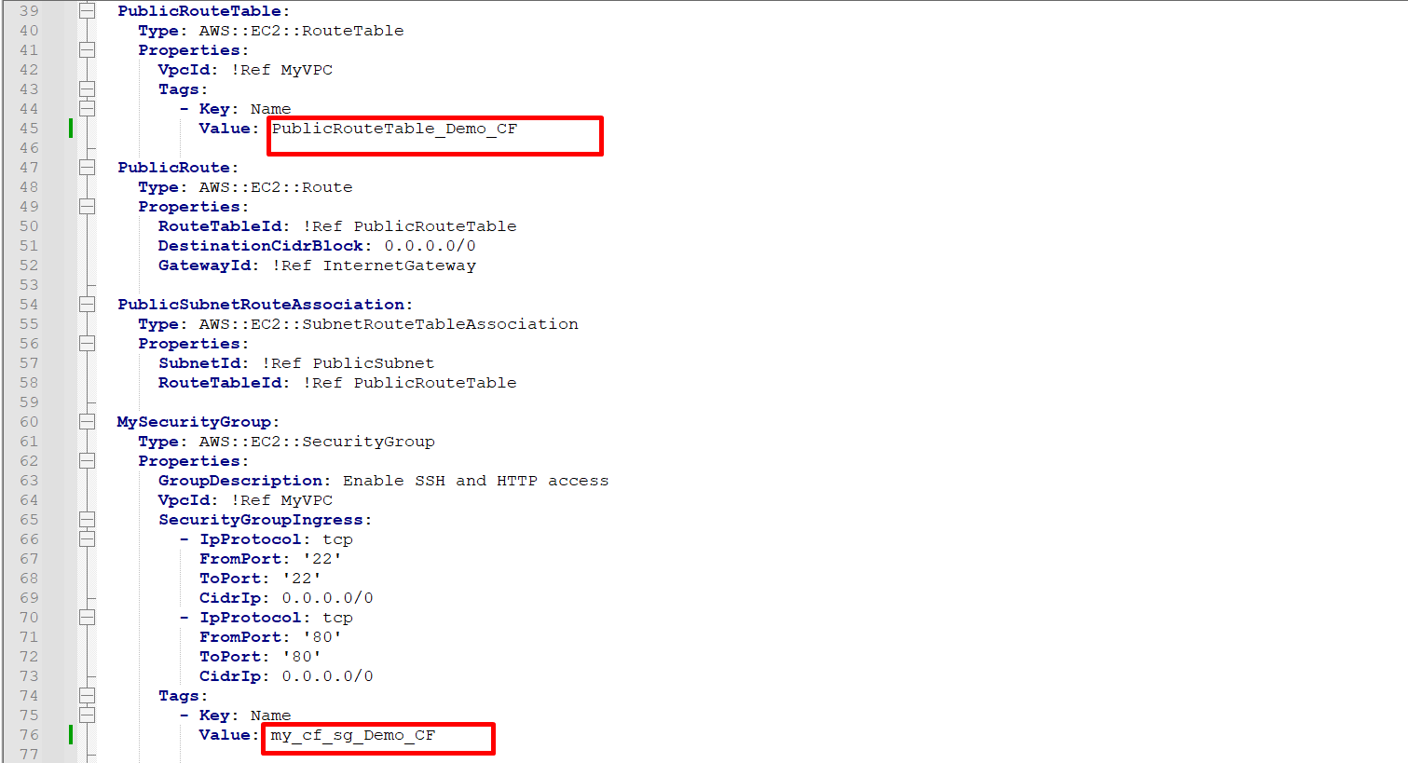

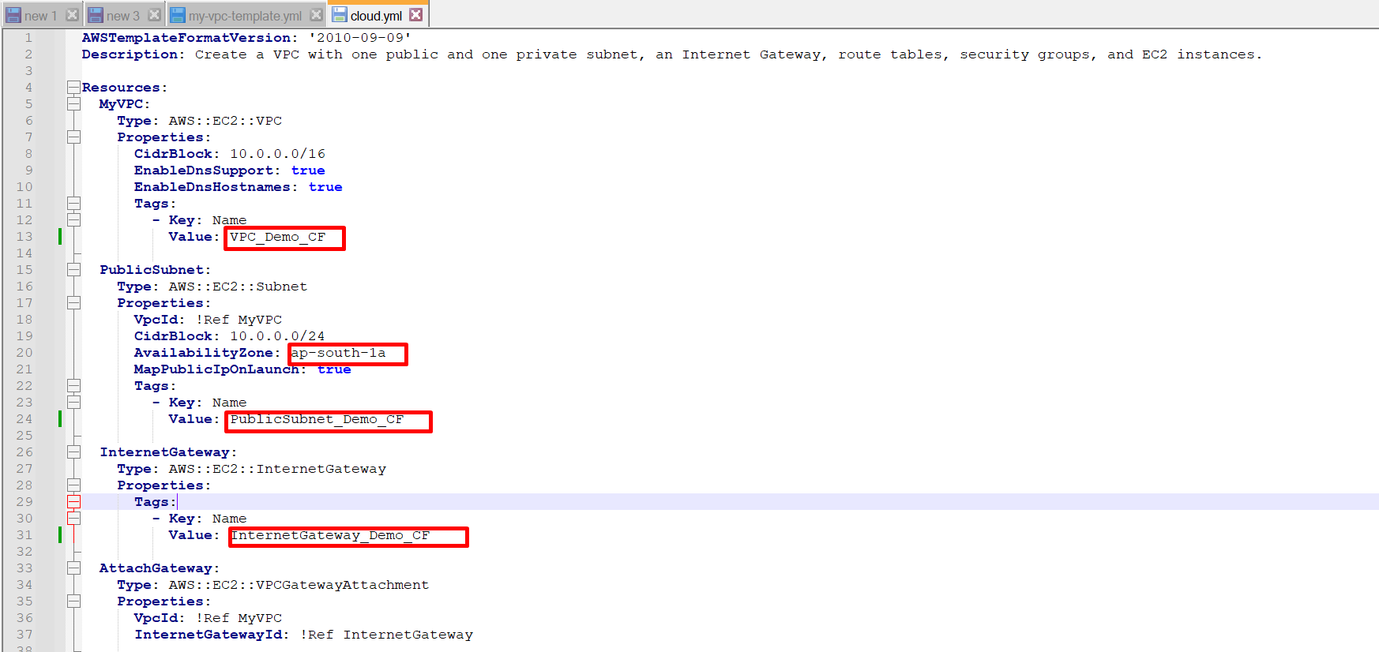

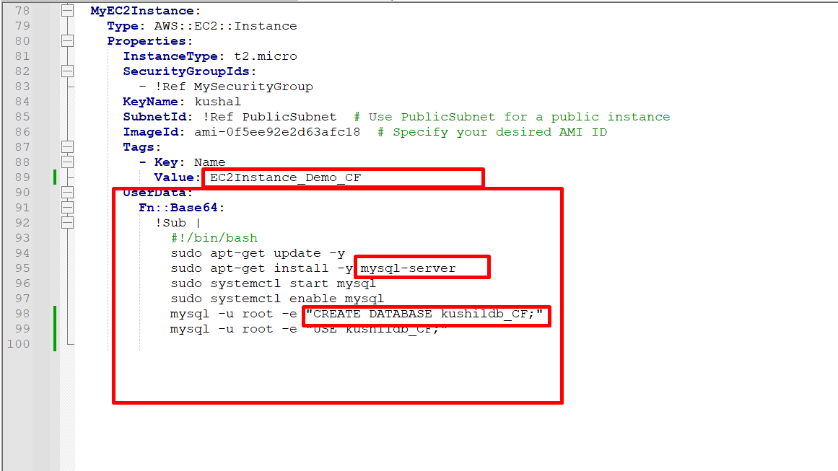

Enter your stack name then click on next.

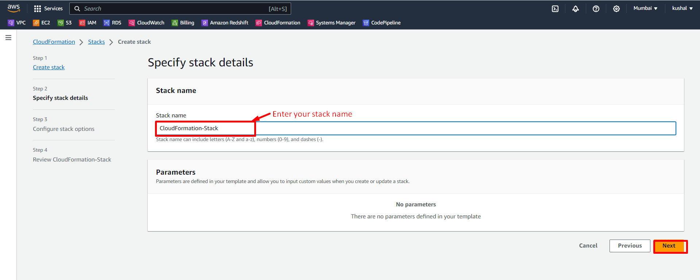

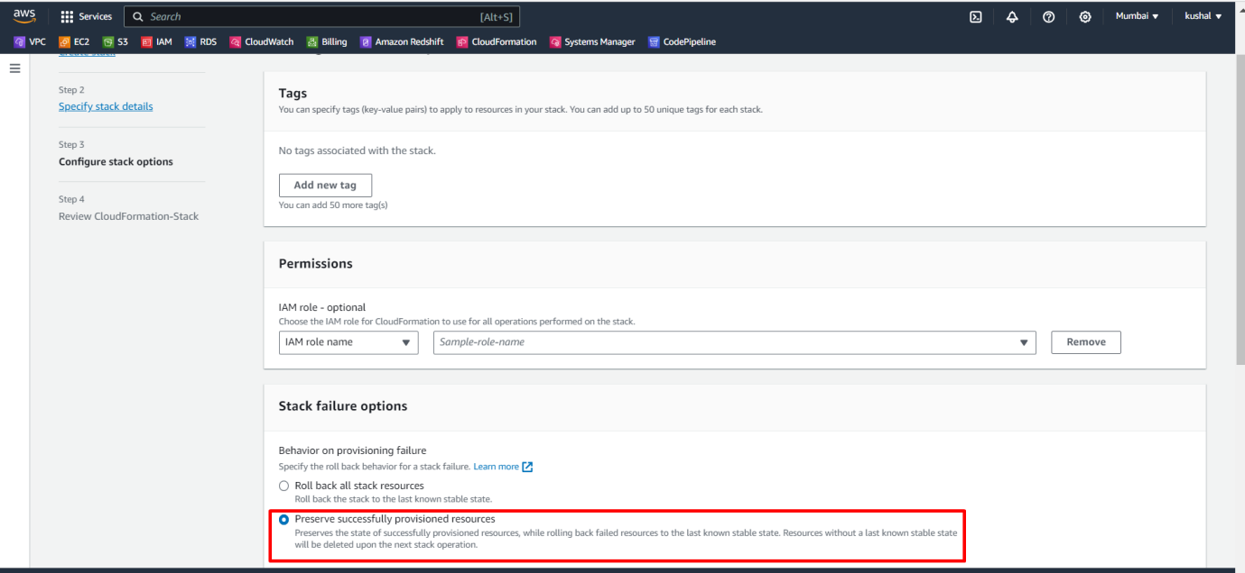

Then click on next.

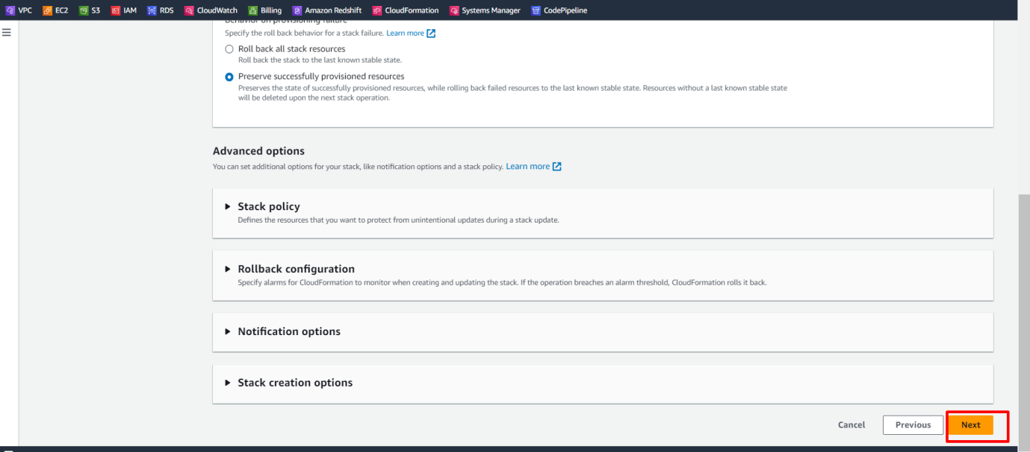

Review your stack once.

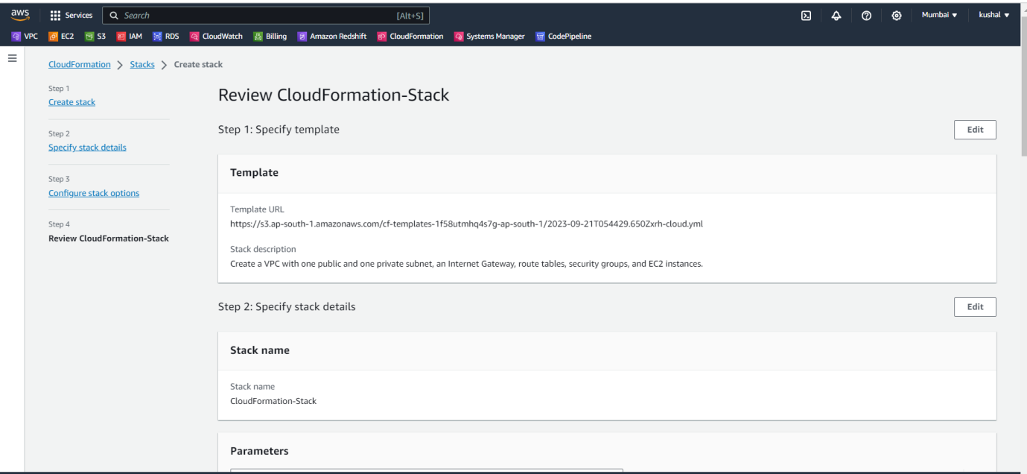

All are over finally click on submit.

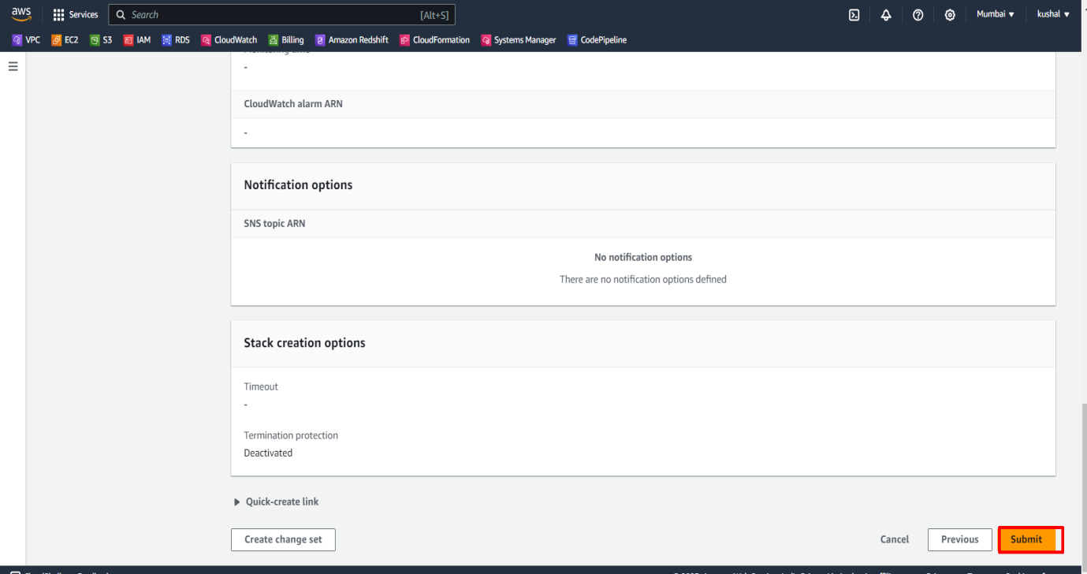

The creating ec2 instance process are in progress.

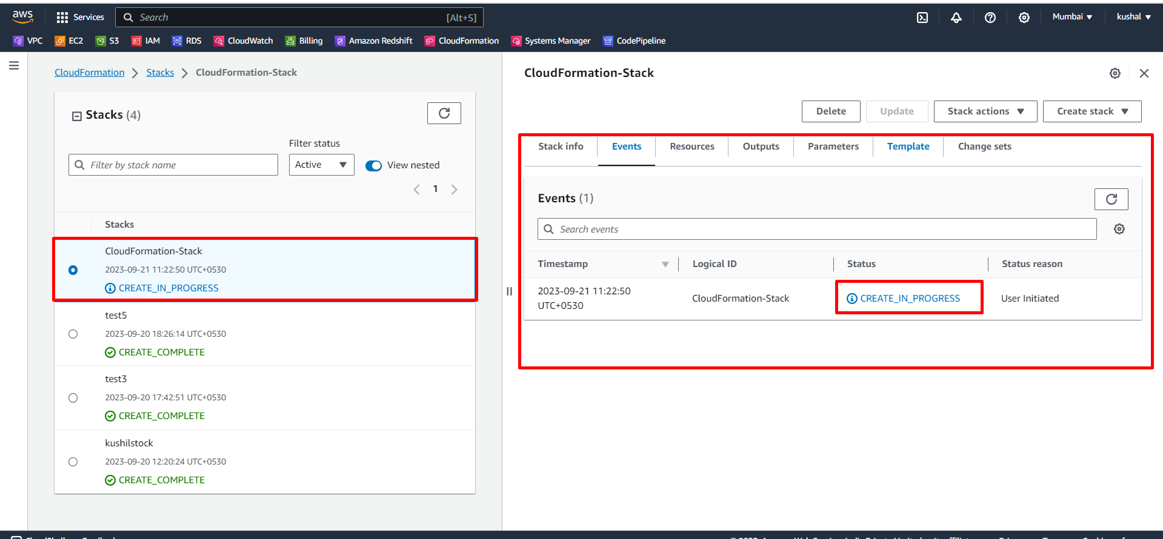

We successfully create an AWS instance with Cloud Formation.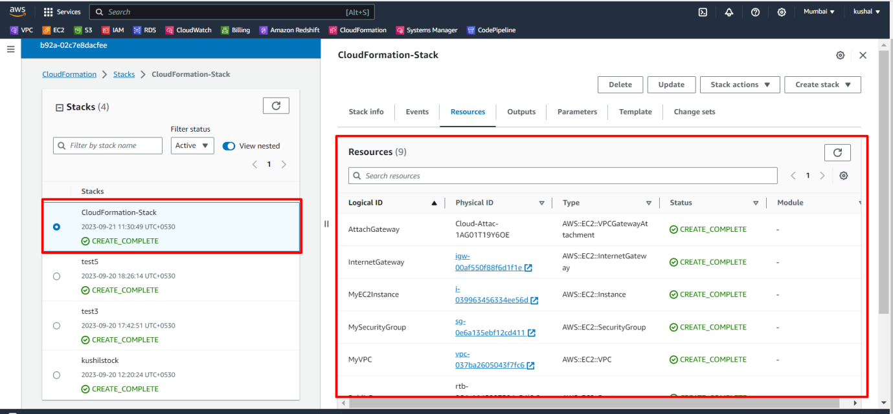

We see our EC2instance_Demo_CF named AWS instance created successfully.

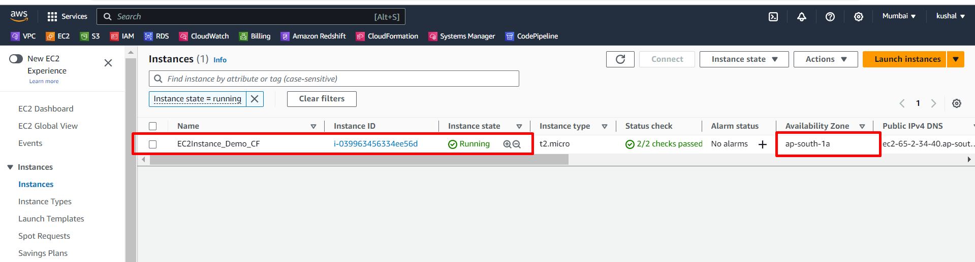

Now we connect and we can see the MySQL database is installed are not.

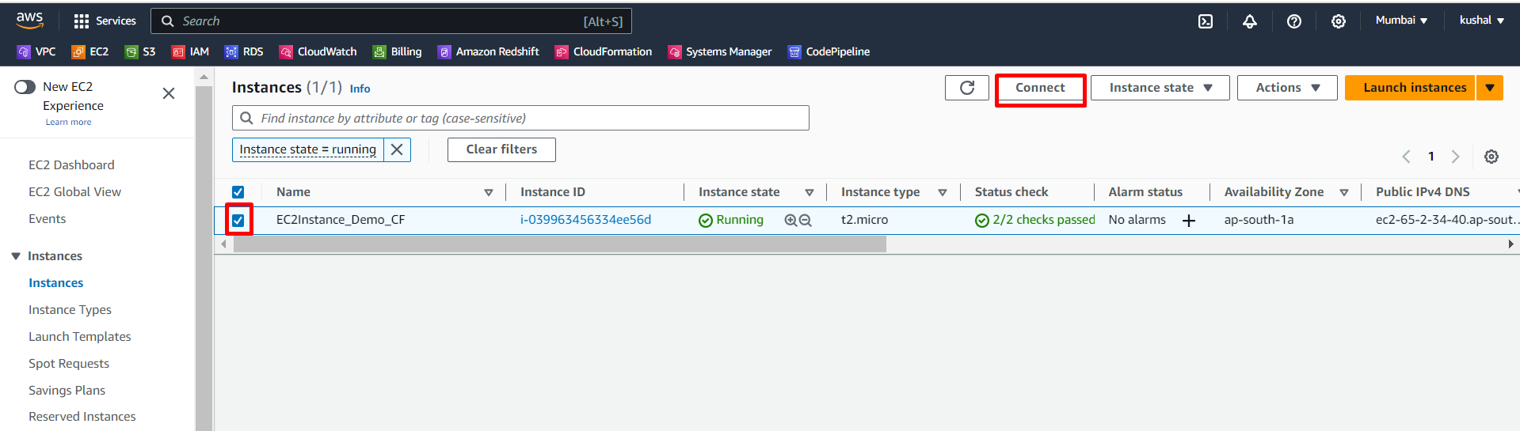

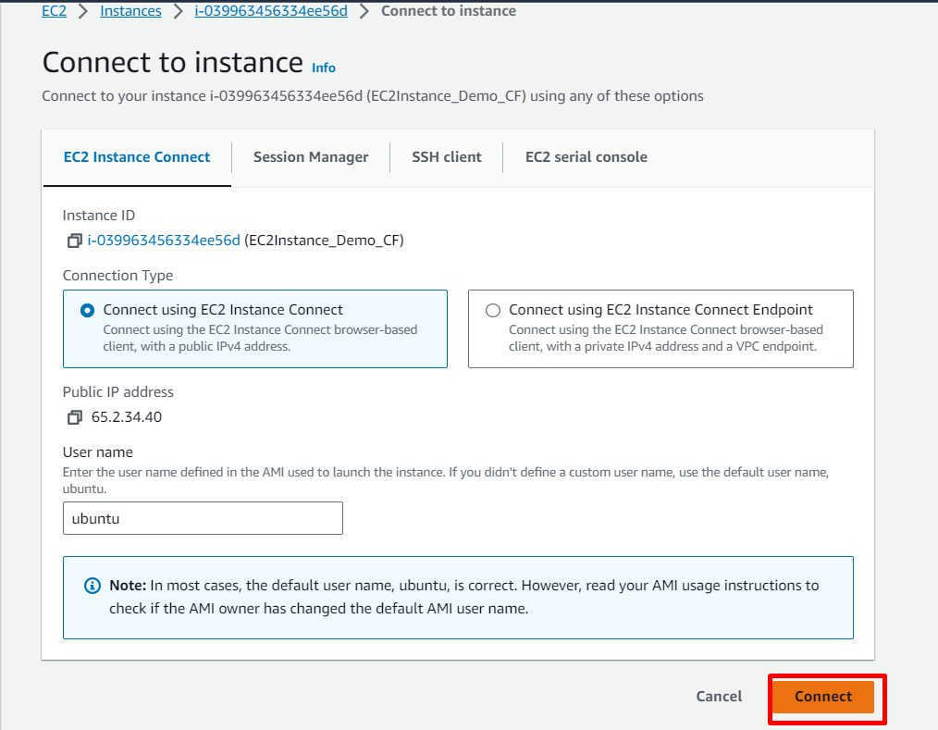

We successfully connected and installed MySQL and also create a database named (kushildb_cf).

These all are created using Cloud Formation code.

